

Relieving & Experience Letter

We hereby certify that **Mehjabeen Naseer khan** has been associated with SquareOne Insights Pvt. Ltd. for the period from 1st March 2023 to 29th February 2024.

We also confirm that **Mehjabeen Naseer khan** got successfully relieved from all her roles and responsibilities

During the time of her tenure we found her extremely resourceful and effective in discharging the responsibilities assigned to her. We take this opportunity to thank her for the services she has rendered to the organization during her tenure.

This is also to confirm that there is **NO DUE** pending to **Mehjabeen Naseer khan** towards full and final settlement of all dues pertaining to earned wages, encashment, notice pay, compensation, leave or any other claim in connection with employment with Squareone.

We wish her all the success in his life, career and future endeavors. Best Regards,

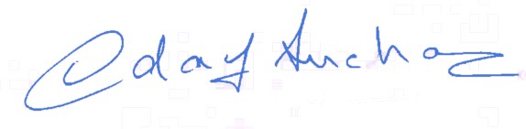

Udaykumar Anchan Business Director

SquareOne Insights Pvt. Ltd.

